**A Summer Internship Report On**

**Web development using Python**

**(Django framework)**

**Submitted In Partial Fulfilment for the course of**

**Summer Internship (3170001)**

## Bachelor of Engineering in Computer Engineering



**Prepared By**

**Ayush Patel** **(191200107035)**

**Industry Guide Faculty Guide**

**Chintan Nagrecha Janaki Barot**

**ADITYA SILVER OAK INSTITUTE OF TECHNOLOGY**

**Gujarat Technological University**

**2022-2023**

**INTERNSHIP COMPLETION CERTIFICATE**

**FORM INDDUSTRY**



**GTU PMMS PORTAL**

**GENERATED COMPLETION** **CERTIFICATE**

**CERTIFICATE**

**Date:**

This is to certify that the Internship at “**Infolabz IT Service**” has been satisfactorily completed by Ayush Patel(191200107035) under my guidance in the fulfilment for the course of Summer Internship (3170001) in Computer Engineering during the academic year 2022-23.



**Prof. Janaki Barot Prof. Jalpa Shah**

Internal Guide HOD(CE Dept)

**ADITYA SILVER OAK INSTITUTE OF TECHNOLOGY**

**Gujarat Technological University**

**2022-2023**

**Acknowledgement**

I/We wish to express our sincere gratitude to our External guide Chintan Thakkar for continuously guiding me at the company and answering all my doubts with patience.

We also thank our parents, friends and all the members of the family for their precious support and encouragement which they had provided in completion of our work. In addition to that, we would also like to mention the company personals who gave us the permission to use and experience the valuable resources required for the internship.

Thus, In conclusion to the above said, we once again thank the staff members of Infolabz IT Service for their valuable support in completion of the project.

Thank You

Ayush Patel

**COMPANY PROFILE**

Established in 2016, incorporation with our parent IT company, INFOLABZ IT SERVICES PVT. LTD. has managed to make it's own position in IT Sector. We are involved in Web Development, App Development, Progressive Web Application Development, IOT solutions, Graphics & Designing, Digital Marketing, Domain & Hosting services, SMS services etc.

In the span of six years, we have managed to deliver all projects on time with utmost accuracy to our clients across the globe. We have dedicated teams of experienced and hard working developers. Our developers who are always willing to take new challenges and looking forward to learn new things, are heart of this company.

Our objective is to sustain with exponential growth in IT industry. Our mission is to deliver the best with top notch quality every quarter and vision is to develop a product with one of its kind concepts which could be used by millions of people.

**Roles and responsibilities during internship :**

* Fulfill the tasks set out by supervisors from several departments.
* Learn and gain experience.
* Conduct on self in a responsible and professional manner.
* Perform clerical duties, take memos maintain files and organize documents.
* Getting familiar with Python Django framework.
* Excellent analytical and problem-solving skills.
* Ability to work well in team.
* Strong work ethic and attention to detail

**Daily tasks and activities**

|  |  |
| --- | --- |
| **DATE** | **ACTIVITIES** |
| 20/06/2022 | Basic knowledge about  Python & Django Framework |
| 21/06/2022 | How to install Django Framework in PyCharm |
| 22/06/2022 | Database connectivity |
| 23/06/2022 | Assignment work |
| 24/06/2022 | API use to print some data print |
| 27/06/2022 | Creating an Application |
| 28/06/2022 | Uses of HTML,CSS,JS on Django |
| 29/06/2022 | Make a normal html page using html , css , and js |
| 30/06/2022 | API use to how to make news site |
| 01/07/2022 | Assignment Work |
| 04/07/2022 | Assignment work submission |

**INTRODUCTION OF TRAINING**

The purpose of industrial Training is to provide exposure for the students on practical engineering fields. Through this exposure, students will have better understanding of engineering practical in general and sense of frequent and possible problems. This training is part of learning process. So the exposure that uplifts the knowledge and experience of a student needs to be properly documented in the form of a report. Through this report, the experience gained can be delivered to their peers. A properly prepared report can facilitate the presentation of the practical experience in an orderly, precise and interesting manner.

I have chosen Python Django as my training because it will help me in several ways. I have chosen my languages course in web development and by having little bit knowledge in this Subject will help me in carrier growth. During learning this I came to understand much more concepts of other language.

**Learning Outcomes from Training**

**General learning outcomes:**

* An understanding of the principles and practice of python in the construction of software’s.
* An awareness of the need for a professional approach to design and the importance of good documentation to the finished programs.
* A competence to design, write , compile , test and execute straightforward programs using a high level language.

**Specific learning outcomes:**

* Be able to implement, compile, test and run programs.
* Understand how to include our logic in a program.

**Task 1:**

Python installation

https://[www.python.org/downloads/](http://www.python.org/downloads/)

PyCharm Install

https://[www.jetbrains.com/pycharm](http://www.jetbrains.com/pycharm)

Prerequisites

Before you continue you should have a basic understanding of the following:

* HTML
* CSS
* JavaScrip

Django Introduction

Django is a web application framework written in Python programming language. It is based on MVT (Model View Template) design pattern. The Django is very demanding due to its rapid development feature. It takes less time to build application after collecting client requirement.

This framework uses a famous tag line: The web framework for perfectionists with deadlines.

By using Django, we can build web applications in very less time. Django is designed in such a manner that it handles much of configure things automatically, so we can focus on application development only

History

Django was design and developed by Lawrence journal world in 2003 and publicly released under BSD

license in July 2005. Currently, DSF (Django Software Foundation) maintains its development and

release cycle.

Django was released on 21, July 2005.

Popularity

Django is widely accepted and used by various well-known sites such as:

oInstagram

oMozilla

oDisqus

oPinterest

oBitbucket

oThe Washington Times

Features of Django

oRapid Development

oSecure

oScalable

oFully loaded

oVersatile

oOpen Source

oVast and Supported Community

Django Installation

To install Django, first visit to django official site (https://www.djangoproject.com) and

download django by clicking on the download section. Here, we will see various options to download

The Django.

History

Django was design and developed by Lawrence journal world in 2003 and publicly released under BSDlicense in July 2005. Currently, DSF (Django Software Foundation) maintains its development and release cycle.

Django was released on 21, July 2005.

Popularity

Django is widely accepted and used by various well-known sites suchas:

* Instagram
* Mozilla
* Disqus
* Pinterest
* Bitbucket
* The Washington Times

**Features of Django**

* Rapid Development
* Secure
* Scalable
* Fully loaded
* Versatile
* Open Source
* Vast and Supported Community

Django Installation

To install Django, first visit to django official site (https://www.djangoproject.com) and download django by clicking on the download section. Here, we will see various options to download The Django.

Django requires pip to start installation. Pip is a package manager system which is used to install and manage packages written in python. For Python 3.4 and higher versions pip3 is used to manage packages.

The installation command is given below.

pip install django

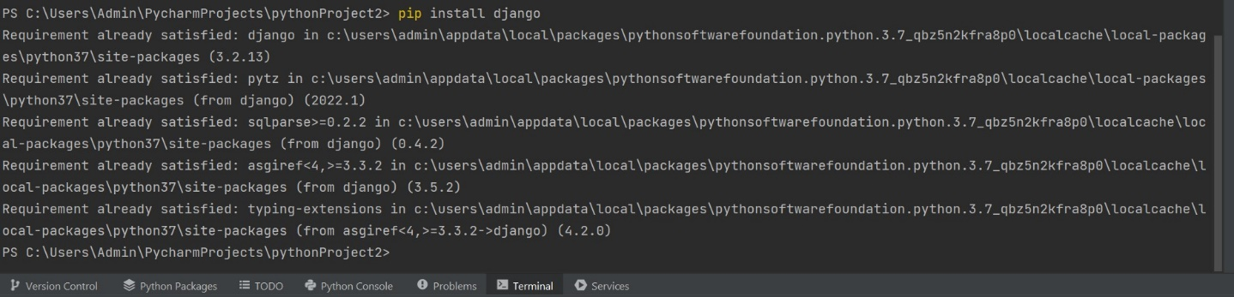pip install django

Check the Django properly installed or not:

Code: django-admin

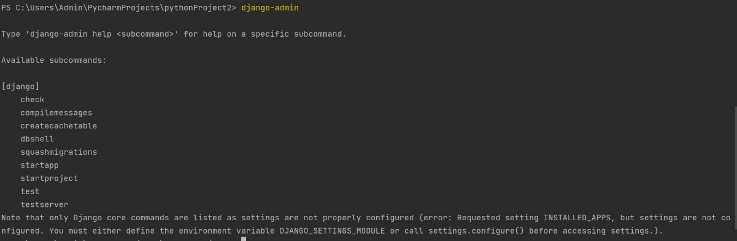

**Create Django project**

Code: django-admin startproject Infolabz .

**New db/table/backend**

Code: python manage.py migrate

**Update/change/link**

Code: python manage.py makemigrations

**Run Django website project**

Code: Python manage.py runserve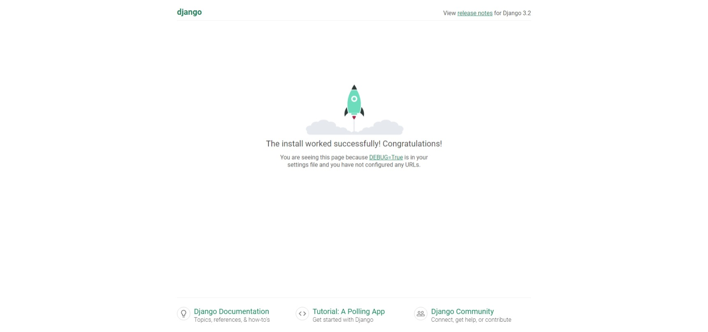r

**Task 2:**

Deployment Of Server And Creating Superuser On Admin Site

After runserver in 127.0.1.8000/admin write to open admin panel

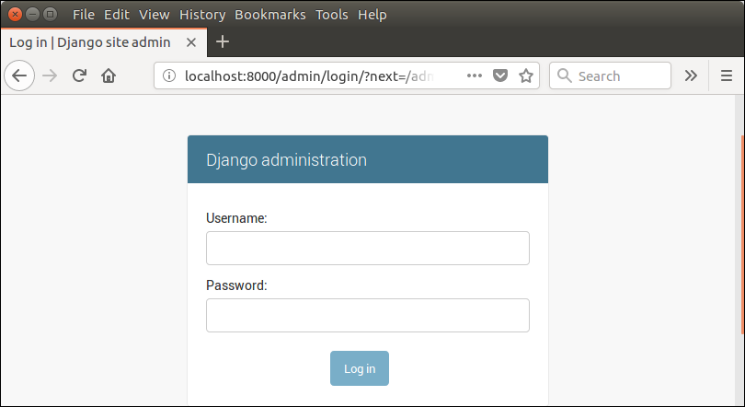

Create an Admin User

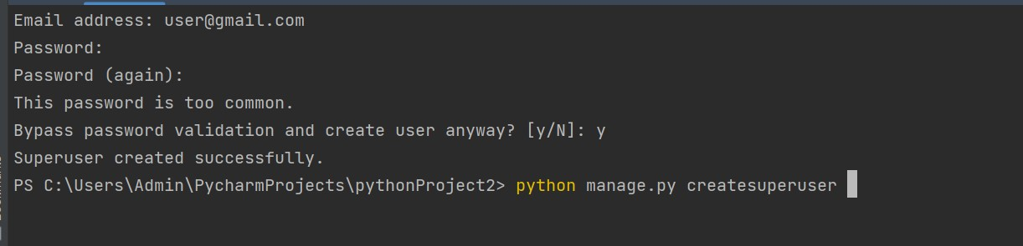Code: python manage.py createsuperuser

Now start development server and access admin login.

$python manage.py runserver

Provide created username and password and login.

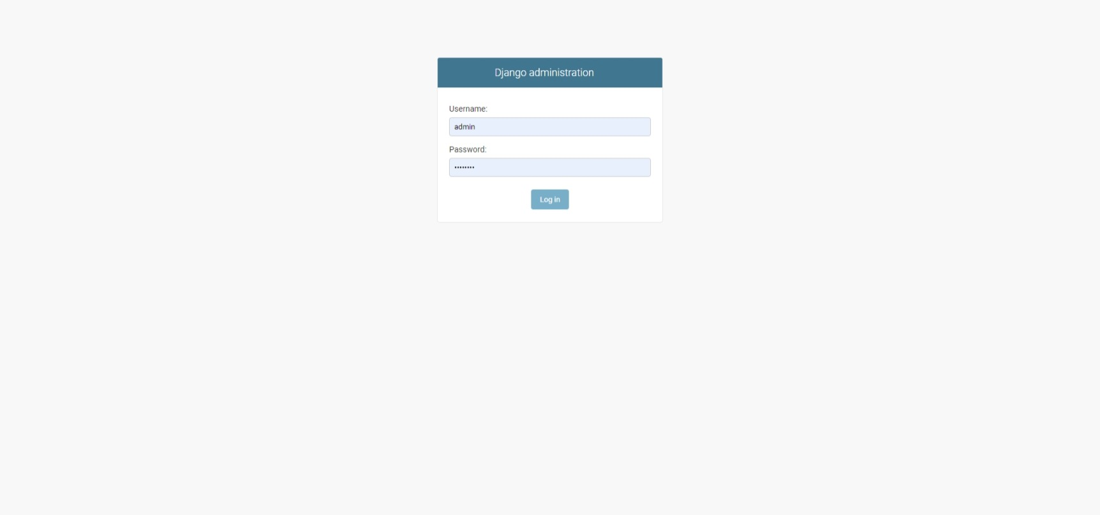

After login successfully, it shows the following interface.

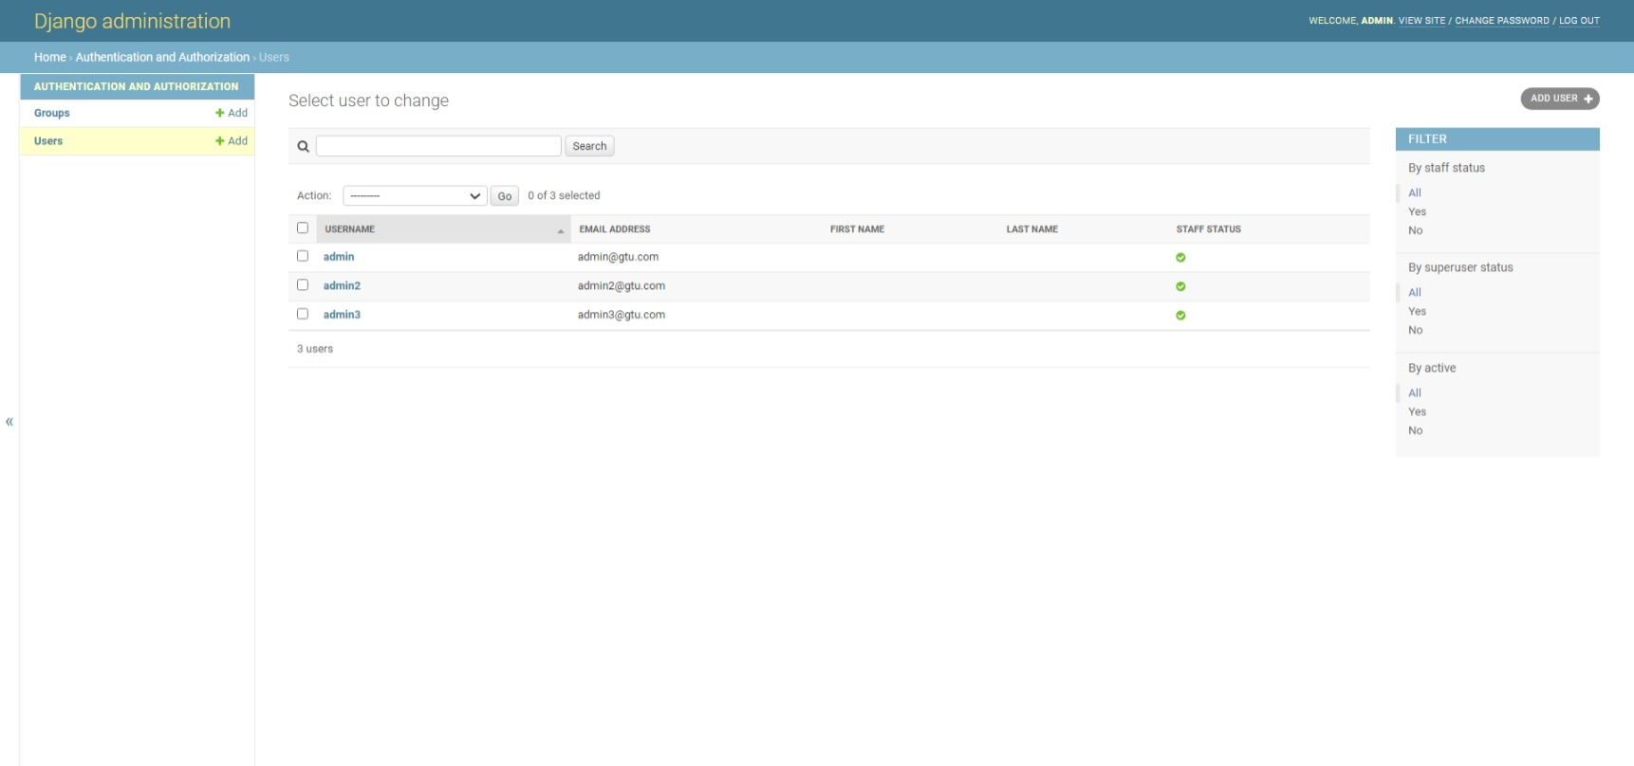

**Create one web page index.html in app (internship) and load it as default page when we run project.**

* For this we will have to create the folder named ‘templates’ which will contain all html files.
* In that folder we will create our ‘index.html’
* Our project name is ‘gtu’ and app name is ‘internship’
* We will make following changes in gtu/urls.py :

from django.contrib import admin  
from django.urls import path, include  
  
urlpatterns = [  
 path('admin/', admin.site.urls),  
 path('',include('internship.urls')),  
]

* For Internship/urls.py:

from django.contrib import admin  
from django.urls import path  
from internship import views  
  
urlpatterns = [  
 path("", views.index, name='internship')  
]

* For Internship/views.py:

from django.shortcuts import render, HttpResponse  
  
# Create your views here.  
def index(request):  
 return render(request, 'index.html')

* When we run this code, we will have the following page as homepage:

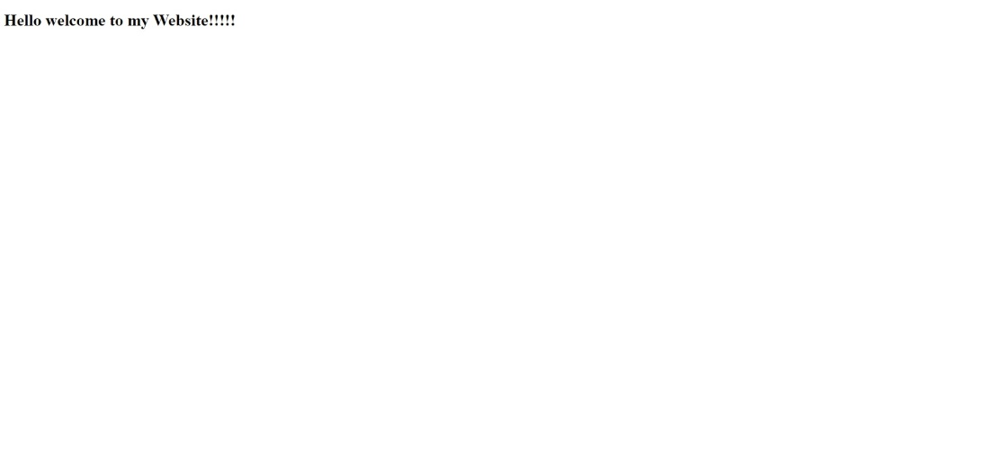

**Task 3: Develop one master news website with different pages of news categories (2-3 pages site and add navigation as well)**

* We are going to use the <https://inshortsapi.vercel.app/news?category=all> API for our website
* This API contains different categories of news which eases our work and we can fetch different news from these categories
* In our website we are going to use these categories: Business, Entertainment, Sports and All which contains all category news.
* We will first configure ‘views.py’ in our app as given below:

from django.shortcuts import render  
import requests  
# Create your views here.  
def index(request):  
 records = {}  
 url = "https://inshortsapi.vercel.app/news?category=all"  
 response = requests.get(url=url)  
 inshorts_data = response.json()  
 records['alldata'] = inshorts_data  
 return render(request,'index.html',records)  
  
def business(request):  
 records = {}  
 url = "https://inshortsapi.vercel.app/news?category=business"  
 response = requests.get(url=url)  
 inshorts_data = response.json()  
 records['businessdata'] = inshorts_data  
 return render(request,'business.html', records)  
  
def entertainment(request):  
 records = {}  
 url = "https://inshortsapi.vercel.app/news?category=entertainment"  
 response = requests.get(url=url)  
 inshorts_data = response.json()  
 records['entertaimentdata'] = inshorts_data  
 return render(request,'entertainment.html', records)  
  
def sports(request):  
 records = {}  
 url = "https://inshortsapi.vercel.app/news?category=sports"  
 response = requests.get(url=url)  
 inshorts_data = response.json()  
 records['sportsdata'] = inshorts_data  
 return render(request,'sports.html', records)  
  
def about(request):  
 return render(request,'about.html')

Here we have installed the requests feature by using command ‘pip install requests’

By using requests, we will request data from the API.

* For navigation from one page to another in the website we will configure the ‘urls.py’ of our Django application as below:

from django.contrib import admin  
from django.urls import path  
from newapp import views  
  
urlpatterns = [  
 path('',views.index,name="indexfile"),  
 path('about.html',views.about,name="aboutfile"),  
 path('index.html',views.index,name="indexfile"),  
 path('business.html',views.business,name="businessfile"),  
 path('entertainment.html',views.entertainment,name="entertainmentfile"),  
 path('sports.html',views.sports,name="sportsfile"),  
  
]

* The code for index.html will be:

<!DOCTYPE html>

<html lang="en">

{% load static %}

    <head>

        <meta charset="utf-8" />

        <meta name="viewport" content="width=device-width, initial-scale=1, shrink-to-fit=no" />

        <meta name="description" content="" />

        <meta name="author" content="" />

        <title>News Site</title>

        <!-- Favicon-->

        <link rel="icon" type="image/x-icon" href="assets/favicon.ico" />

        <!-- Core theme CSS (includes Bootstrap)-->

        <link href="css/styles.css" rel="stylesheet" />

        <link href="https://cdnjs.cloudflare.com/ajax/libs/font-awesome/6.0.0/css/all.min.css" rel="stylesheet"/>

        <!-- Google Fonts -->

        <link href="https://fonts.googleapis.com/css?family=Roboto:300,400,500,700&display=swap" rel="stylesheet"/>

        <!-- MDB -->

        <link href="https://cdnjs.cloudflare.com/ajax/libs/mdb-ui-kit/4.2.0/mdb.min.css" rel="stylesheet"/>

        <link href="https://cdn.jsdelivr.net/npm/bootstrap@5.2.0-beta1/dist/css/bootstrap.min.css" rel="stylesheet" integrity="sha384-0evHe/X+R7YkIZDRvuzKMRqM+OrBnVFBL6DOitfPri4tjfHxaWutUpFmBp4vmVor" crossorigin="anonymous">

        <link rel="stylesheet" href="https://cdn.jsdelivr.net/npm/bootstrap@4.4.1/dist/css/bootstrap.min.css" integrity="sha384-Vkoo8x4CGsO3+Hhxv8T/Q5PaXtkKtu6ug5TOeNV6gBiFeWPGFN9MuhOf23Q9Ifjh" crossorigin="anonymous">

        <!-- JavaScript Bundle with Popper -->

        <script src="https://cdn.jsdelivr.net/npm/bootstrap@5.2.0-beta1/dist/js/bootstrap.bundle.min.js" integrity="sha384-pprn3073KE6tl6bjs2QrFaJGz5/SUsLqktiwsUTF55Jfv3qYSDhgCecCxMW52nD2" crossorigin="anonymous"></script>

        <script src="https://code.jquery.com/jquery-3.4.1.slim.min.js" integrity="sha384-J6qa4849blE2+poT4WnyKhv5vZF5SrPo0iEjwBvKU7imGFAV0wwj1yYfoRSJoZ+n" crossorigin="anonymous"></script>

        <script src="https://cdn.jsdelivr.net/npm/popper.js@1.16.0/dist/umd/popper.min.js" integrity="sha384-Q6E9RHvbIyZFJoft+2mJbHaEWldlvI9IOYy5n3zV9zzTtmI3UksdQRVvoxMfooAo" crossorigin="anonymous"></script>

        <script src="https://cdn.jsdelivr.net/npm/bootstrap@4.4.1/dist/js/bootstrap.min.js" integrity="sha384-wfSDF2E50Y2D1uUdj0O3uMBJnjuUD4Ih7YwaYd1iqfktj0Uod8GCExl3Og8ifwB6" crossorigin="anonymous"></script>

        <link href="//maxcdn.bootstrapcdn.com/bootstrap/4.0.0/css/bootstrap.min.css" rel="stylesheet" id="bootstrap-css">

        <script src="//maxcdn.bootstrapcdn.com/bootstrap/4.0.0/js/bootstrap.min.js"></script>

        <script src="//cdnjs.cloudflare.com/ajax/libs/jquery/3.2.1/jquery.min.js"></script>

    <!------ Include the above in your HEAD tag ---------->

        <!-- MDB -->

        <script type="text/javascript" src="https://cdnjs.cloudflare.com/ajax/libs/mdb-ui-kit/4.2.0/mdb.min.js"></script>

    </head>

    <body>

        <div class="d-flex" id="wrapper">

            <!-- Page content wrapper-->

            <div id="page-content-wrapper">

                <!-- Top navigation-->

                <nav class="navbar navbar-expand-lg navbar-light bg-light border-bottom">

                    <div class="container-fluid">

                        <a class="navbar-brand" href="#"><img src="{% static 'images/news.png'%}" style="height:33px;width:33px;">News</a>

                        <button class="navbar-toggler" type="button" data-bs-toggle="collapse" data-bs-target="#navbarSupportedContent" aria-controls="navbarSupportedContent" aria-expanded="false" aria-label="Toggle navigation"><span class="navbar-toggler-icon"></span></button>

                        <div class="collapse navbar-collapse" id="navbarSupportedContent">

                            <ul class="navbar-nav ms-auto mt-2 mt-lg-0">

                                <li class="nav-item active"><a class="nav-link" href="{% url 'indexfile' %}">Home</a></li>

                                <li class="nav-item active"><a class="nav-link" href="{% url 'nationalfile' %}">National</a></li>

                                <li class="nav-item active"><a class="nav-link" href="{% url 'politicsfile' %}">Politics</a></li>

                                <li class="nav-item dropdown">

                                    <a class="nav-link dropdown-toggle" id="navbarDropdown" href="#" role="button" data-bs-toggle="dropdown" aria-haspopup="true" aria-expanded="false">All</a>

                                    <div class="dropdown-menu dropdown-menu-end" aria-labelledby="navbarDropdown">

                                        <a class="dropdown-item" href="{% url 'automobilefile' %}">Automobile</a>

                                        <a class="dropdown-item" href="{% url 'businessfile' %}">Business</a>

                                        <a class="dropdown-item" href="{% url 'educationfile' %}">Education</a>

                                        <a class="dropdown-item" href="{% url 'entertainmentfile' %}">Entertainment</a>

                                        <a class="dropdown-item" href="{% url 'hatkefile' %}">Hatke</a>

                                        <a class="dropdown-item" href="{% url 'healthfile' %}">Health</a>

                                        <a class="dropdown-item" href="{% url 'internationalfile' %}">International</a>

                                        <a class="dropdown-item" href="{% url 'miscellaneousfile' %}">Miscellaneous</a>

                                        <a class="dropdown-item" href="{% url 'nationalfile' %}">National</a>

                                        <a class="dropdown-item" href="{% url 'sciencefile' %}">Science</a>

                                        <a class="dropdown-item" href="{% url 'sportsfile' %}">sports</a>

                                        <a class="dropdown-item" href="{% url 'startupfile' %}">Startup</a>

                                        <a class="dropdown-item" href="{% url 'technologyfile' %}">Technology</a>

                                        <a class="dropdown-item" href="{% url 'worldfile' %}">World</a>

                                    </div>

                                </li>

                            </ul>

                        </div>

                    </div>

                </nav>

                <!-- Page content-->

                <div class="container-fluid">

                    <div class="card-group">

                        {% for value in data.data %}

                          <div class="col-md-4">

                              <div>

                                  <img class="card-img-top" src="{{ value.imageUrl }}" alt="Card image cap" style=" margin:0.5rem;height:25rem">

                                <div class="card-body">

                                  <h5 class="card-title">{{ value.title }}</h5>

                                  <p class="card-text">{{ value.content }}</p>

                                    <a href="{{value.readMoreUrl}}" class="card-link">Read More</a>

                                    <a href="{{value.url}}" class="card-link">Url</a>

                                </div><br>

                              </div>

                          </div>

                        {% endfor %}

                    </div>

                </div>

            </div>

        </div>

    </body>

</html>

* The output of index page will look like this:

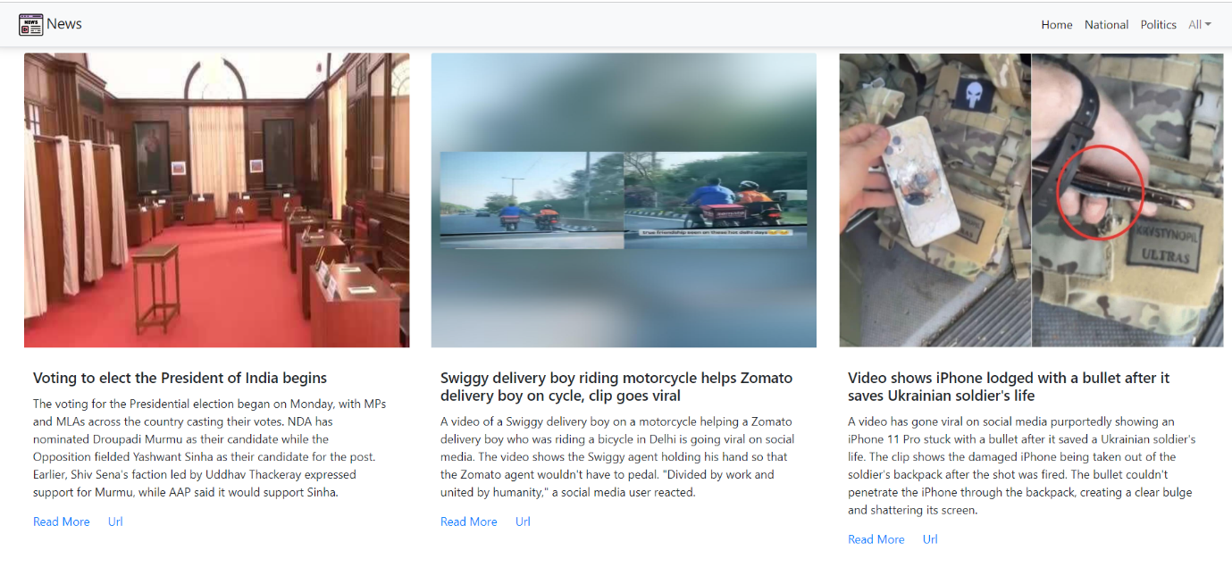

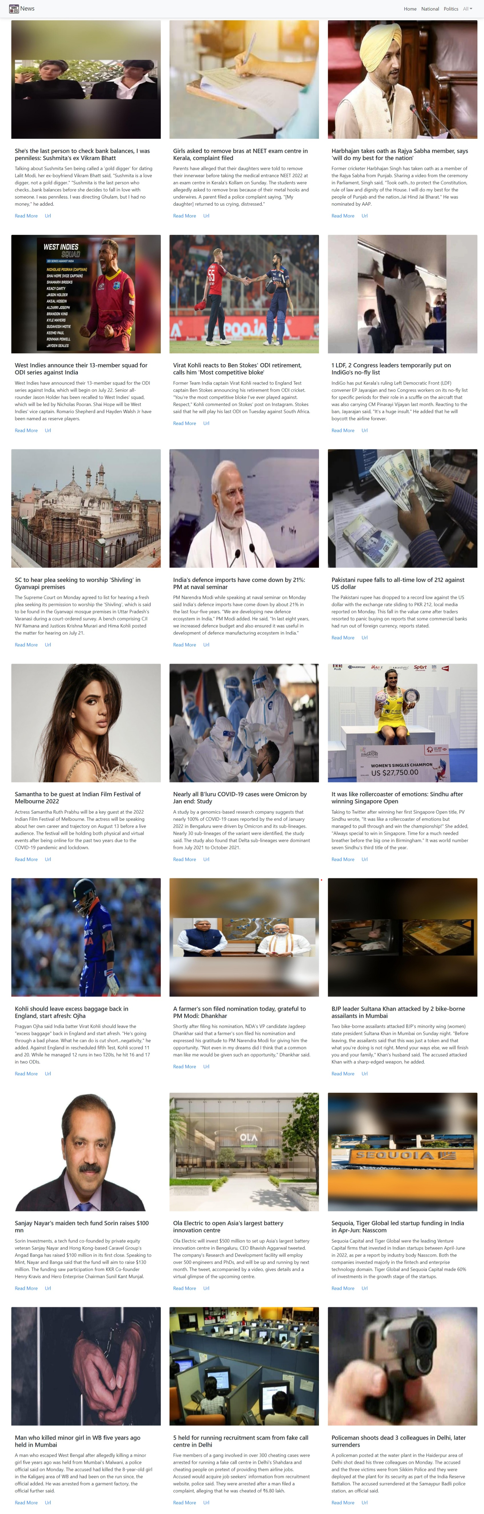

* Similarly, we will create business.html, entertsinment.html and sports.html
* Their outputs will be:

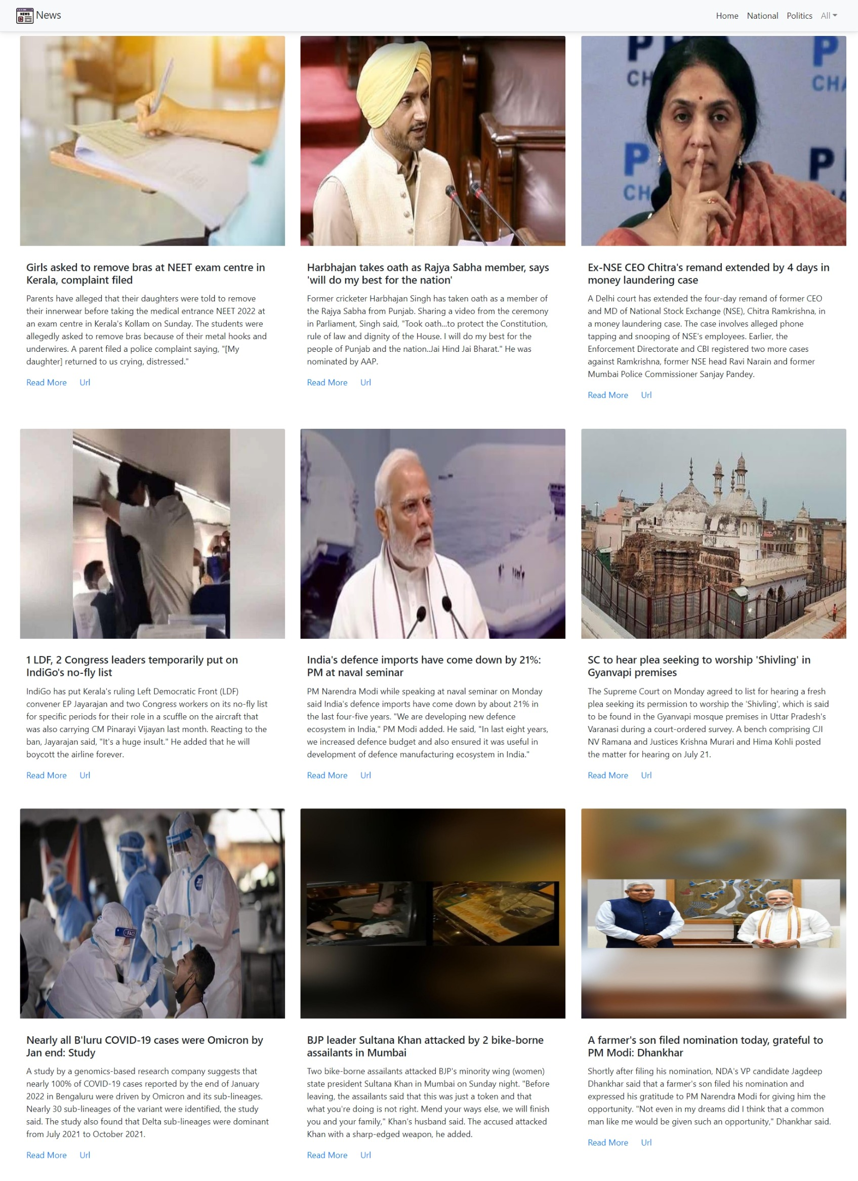

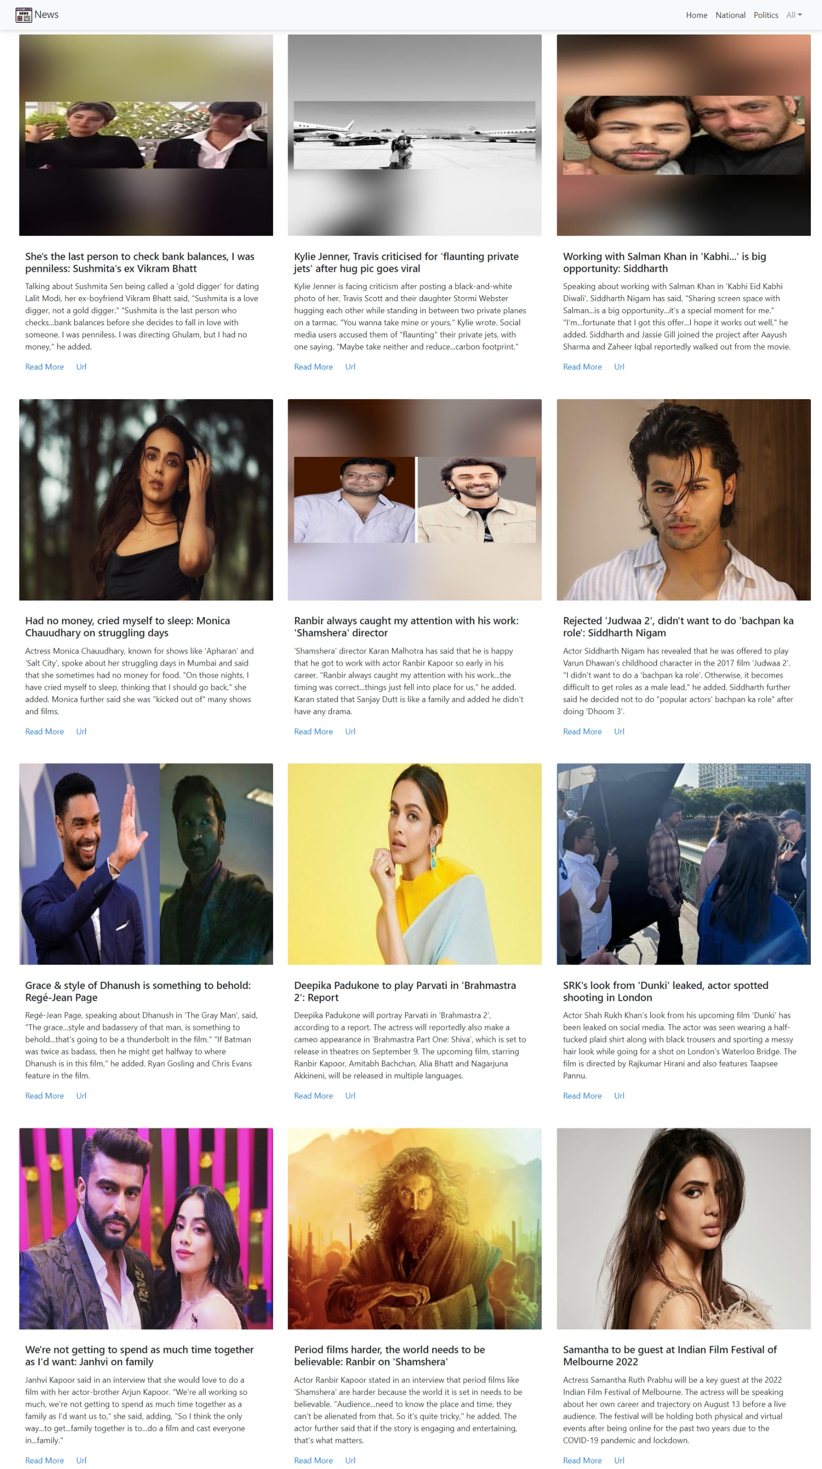

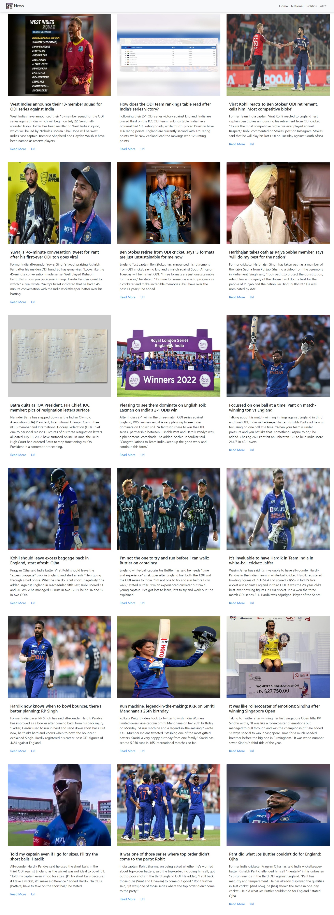

**Skills Learned**

**About the skills**

**Planning:**

The ability to think about and successfully manage activities, with the help of any available resources to achieve specific goals.

**Problem solving skills:**

No employer wants a worker who continually hits brick walls in the course of their daily work; Instead they want somebody capable of using their initiative and seeking out their own solutions.

**Practical skills:**

Of course, each job role is different and you will encounter different software system and tools depending on your chosen profession.

**Python**

Python is a computer programming language often used to build websites and software, automate tasks, and conduct data analysis. Python is a general-purpose language, meaning it can be used to create a variety of different programs and isn’t specialized for any specific problems. This versatility, along with its beginner-friendliness, has made it one of the most-used programming languages today.

**Django framework**

Django is a web application framework written in Python programming language. The Django is very demanding due to its rapid development feature. It takes less time to build application after collecting client requirement.

This framework uses a famous tag line: The web framework for perfectionists with deadlines

**API**

An API (Application Programming Interface) is a set of functions that allows applications to access data and interact with external software components, operating systems, or microservices. To simplify, an API delivers a user response toa system and sends the system's response back to a user

**Overall Experience**

**Technical Experience:**

In this internship I learnt about Django framework along with an understanding of MVC architecture. I have also worked on JSON structures as well as different API(s) and API fetching in web pages using the Django framework

**Personal Experience:**

It was very good experience for me to work with infolabz, The management was very responsive and supportive. I have gained new knowledge and skills.

**Conclusion**

I can honestly say that my time spent interning with Infolabz IT Service resulted in one of the best summers of my life. Not only did I gain practical skills but I also had the opportunity to meet many fantastic people.